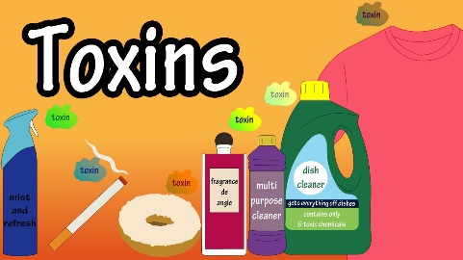 Reducing Your Toxic Load

Waunea Woods Morrison, Nutrition/Wellness Consultant, Essential Oils Distributor

What are toxins?
- Poisons that are unstable and harmful when introduced to the body; causes tissue damage when left untreated
Where do toxins come from?
- Internal – processed foods, body care/household products, medications, normal chemical reactions that occur in our body every day; body produces waste that must be removed
- External - pollutants in the air (cigarette smoke, car exhaust, fires)
- Behavioral – unmanaged stress/anger/strife/un-forgiveness, poor sleeping habits, smoking/alcohol
What are signs of toxicity?
- Chronic diseases, swelling, joint inflammation
What is a detox?
- A process of removing toxic waste from the body by avoiding specific foods/practices
How do we remove/reduce toxic exposure?
- Cooperate with body’s natural detox process
- Eat organic foods/essential oils that have detox properties
- Avoid foods/environments that are prone to toxins
- Eat alkaline diet/foods with natural detox properties
- Reduce chemical exposure (internal, external, behavioral)
- Detox program (Nutrition Consult, essential oils)
Which essential oils help to remove toxins from our body?
- Antimicrobial, antioxidant, and anti-inflammatory properties (eucalyptus, lemon, ginger, rosemary, basil, peppermint, lavender, cinnamon)
Tips:
- Include foods/essential oils high in antioxidants to boost your immune system
- Reduce chemical exposure (body care, household, plastics, eat organic)
- Avoid produce that have higher amounts of pesticides/toxins
- Buy organic produce whenever possible; wash conventionally grown produce
- Take a quality food-based multivitamin daily
- Exercise/sauna to the point of raising body temperature/sweating
- Organic gardening with natural insect repellants

